Chapter 15, Solution 15.

This is a periodic function with T=3.
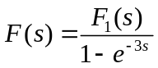
To get F₁(s), we consider f(t) over one period.

f₁(t) f₁’(t) f₁’’(t)
–5δ(t-1)
–5δ(t-1)
–5δ’(t-1)

5 5
5δ(t)

0 1 t 0 1 t 0 1 t

f₁” = 5δ(t) –5δ(t–1) – 5δ’(t–1)

Taking the Laplace transform of each term,

s²F₁(s) = 5 –5e^{–s} – 5se^{–s} or F₁(s) = 5(1 – e^{–s} – se^{–s})/s²

Hence,

F(s) = 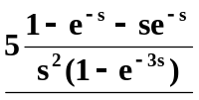
Alternatively, we can obtain the same answer by noting that f₁(t) = 5tu(t) – 5tu(t–1) – 5u(t–1).

